

**DBMS PROJECT REPORT**

**(Project Semester August-December 2022)**

**HOTEL MANAGEMENT SYSTEM**

**Submitted By**

**Anshika Nigam**

**Reg No: 12112925**

**Roll No: 20**

**Program &** **Section: BTech CSE K21RT**

**Course Code: INT306**

**Under the guidance of: Mr. Karthick Panneerselvam**

**CERTIFICATE**

This is to certify that Anshika Nigam bearing Registration no 12112925 has completed INT 306 project titled, **“Hotel Management System”** under my guidance and supervision. To the best of my knowledge, the present work is the result of his/her original development, effort and study.

**Signature and Name of the Supervisor**

**Designation of the Supervisor**

**School of Computer Science.**

Lovely Professional University

Phagwara, Punjab.

Date:14.11.2022

**DECLARATION**

I, Anshika Nigam, student of P132 Btech under CSE/IT Discipline at, Lovely Professional University, Punjab, hereby declare that all the information furnished in this project report is based on my own intensive work and is genuine.

Date: 14 November,2022. Signature

Registration No: 12112925 Name of the student: Anshika Nigam

**TABLE OF CONTENTS**

1. Acknowledgement
2. Abstract
3. Introduction
4. Project Description
5. Entities and Attributes
6. ER-Diagram (Conceptual Model)
7. Schema Diagram
8. Final List of Relations
9. Create and Insert SQL And PL/SQL Queries
10. SQL Queries related to Report Generation
11. Conclusion

**ACKNOWLEDGEMENTS**

It is great pleasure for me to express my gratitude to our Head of Faculty Dr. Lavi Raj Gupta, for giving the opportunity and platform with facilities in accomplishing the project-based laboratory report.

I express the sincere gratitude to our Head of School Dr. Deepak Prashar for his administration towards our academic growth.

I express sincere gratitude to our Head of Department Dr. Dalwinder Singh for his leadership and constant motivation provided in successful completion of our academic semester. I record it as my privilege to deeply thank, for providing us the efficient faculty and facilities to make our ideas into reality.

I express my sincere thanks to our project supervisor Mr. Karthick Panneerselvam for his novel association of ideas, encouragement, appreciation and intellectual zeal which motivated us to venture this project successfully.

Finally, it is pleased to acknowledge the indebtedness to all those who devoted themselves directly or indirectly to make this project report success.

**PROJECT ASSOCIATE**

**Name: Anshika Nigam**

**Reg No: 12112925**

**ABSTRACT**

The Project HOTEL MANAGEMENT SYSTEM is a SQL based application that allows the hotel manager to handle all hotel activities online. Interactive interface and the ability to manage various hotel bookings and rooms make this system very flexible and convenient.

The hotel manager is a very busy person and does not have the time to sit and manage the entire activities manually on paper. This application gives him the power and flexibility to manage the entire system from a single online system.

Hotel Management project provides room booking, staff management and other necessary hotel management features. The system allows the manager to post available rooms in the system. Customers can view and book room online.

Admin has the power of either approving or disapproving the customer's booking request. Other hotel services can also be viewed by the customers and can book them too. The system is hence useful for both customers and managers to portably manage the hotel activities.

**INTRODUCTION**

Database is an organized collection of data. The data is typically organized to model aspects of reality in a way that supports processes requiring information. A DBMS makes it possible for end users to create, read, update and delete data in a database. The DBMS essentially serves as an interface between the database and end users or application programs, ensuring that data is consistently organized and remains easily accessible. The DBMS manages three important things: the data, the database engine that allows data to be accessed, locked and modified and the database schema, which defines the database’s logical structure. These three foundational elements help provide concurrency, security, data integrity and uniform administration procedures. The DBMS can offer both logical and physical data independence. That means it can protect users and applications from needing to know where data is stored or having to be concerned about changes to the physical structure of data.

The main purpose of maintaining database for Railway Reservation System is to reduce the manual errors involved in the booking and cancelling of tickets and make it convenient for the customers and providers to maintain the data about their customers and also about the seats available at them. Due to automation many loopholes that exist in the manual maintenance of the records can be removed. The speed of obtaining and processing the data will be fast. For future expansion the proposed system can be web enabled so that clients can make various enquiries about trains between stations. Due to this, sometimes a lot of problems occur, and they are facing many disputes with customers. To solve the above problem, we design a data base which includes customer details, availability of seats in trains, no of trains and their details.

Project Description

The hotel management system should be able to satisfy the following requirements:

1. The system should be able to keep the records of the guests and the room allotted to them.

2. Customers should be able to know the availability of the rooms on a particular date.

3. Guests should be able to book the available rooms online.

4. The record of food and services availed by the customer should be kept.

5. The system should be able to generate the bill for a customer.

**ENTITIES AND ATTRIBUTES**

|  |  |
| --- | --- |
| **ENTITIES** | **ATTRIBUTES** |
| Guest | Guest_ID |
| Family | Family_Head_Name, Family_Head_SSN, Address,Phone_No,No_Of_Adults,No_Of_Children |
| Family Members | Family_Head_SSN, Name, Age |
| COMPANY | Name,Location |
| Company Members | CName,Name,Age,Designation |
| Room | Road_No,Type,Rate,Status,Guest_ID,Chech_In_Date,Check_Out_Date |
| Facilities | Facility_ID,Rate,Type,Guest_ID |
| Bill | Bill_No,Amount,date_order,Paying_Method,Guest_ID |
| Food | Product_ID,Rate,Type |
| Orders | Guest_ID,Product_ID,date_order,Time,Quantity |

**ER-Diagram (Conceptual Model)**

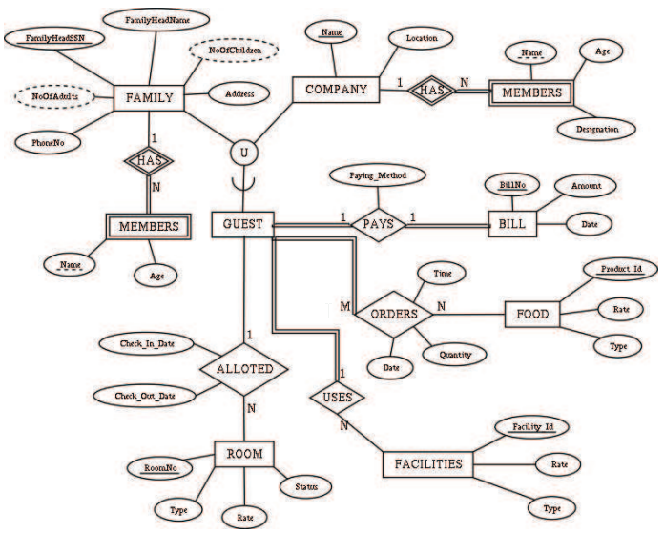

**SCHEMA DIAGRAM**

**FAMILY**

|  |  |  |  |  |  |
| --- | --- | --- | --- | --- | --- |
| Family_Head_SSN | Family_Head_Name | Address | Phone_No | No_Of_Adults | No_Of_Children |

**FAMILY MEMBERS**

|  |  |  |
| --- | --- | --- |
| Family_Head_SSN | Name | Age |

**COMPANY**

|  |  |
| --- | --- |
| Name | Location |

**COMPANY MEMBERS**

|  |  |  |  |
| --- | --- | --- | --- |
| CName | Name | Age | Designation |

**GUEST**

|  |
| --- |
| Guest_ID |

**ROOM**

|  |  |  |  |  |  |  |
| --- | --- | --- | --- | --- | --- | --- |
| Room_No | Type | Rate | Status | Guest_ID | Check_In_Date | Check_Out_Date |

**FACILITIES**

|  |  |  |  |
| --- | --- | --- | --- |
| Facility_ID | Rate | Type | Guest_ID |

**BILL**

|  |  |  |  |  |
| --- | --- | --- | --- | --- |
| Bill_No | Amount | date_order | Paying_Method | Guest_ID |

**FOOD**

|  |  |  |
| --- | --- | --- |
| Product_ID | Rate | Type |

**ORDERS**

|  |  |  |  |  |
| --- | --- | --- | --- | --- |
| Guest_ID | Product_ID | date_order | Time | Quantity |

The Functional Dependencies are shown in the figure.

According to the figure:

1. In all Tables attribute values are atomic hence they are in 1NF.

2. In all tables there is no partial dependency and hence they are in 2NF.

3. There is no transitive dependency at all , so they are in 3NF.

4. All tables are also in BCNF because left hand side of all FDs contain only primary key (which is of course superkey) corresponding to their respective relation. So, we can conclude that tables are in BCNF.

**FINAL LIST OF RELATIONS**

1. GUEST are ALLOTED ROOM from CheckInDate to CheckOutDate. One Guest(Family or Company) can be alloted more than one room.

2. GUEST PAYS BILL. A GUEST must pay a BILL.

3. GUEST may USES FACILITIES. One GUEST can use more than one FACILITIES.

4. GUEST ORDERS FOOD at some Time on some Date. GUEST can order more than one FOOD item and one FOOD item can be ordered by one GUEST.

**CREATE AND INSERT SQL And PL/SQL QUERIES**

**1.** create table Family (Family_Head_SSN int,Family_Head_Name varchar (100), Address varchar (100),Phone_No int,No_Of_Adults int,No_Of_Children int);

INSERT INTO FAMILY (Family_Head_SSN,Family_Head_Name,Address,Phone_No,No_Of_Adults, No_Of_Children) VALUES ('10', 'MR. ROHAN SHARMA', 'NOIDA', '9086435781', '2', '2');

INSERT INTO FAMILY (Family_Head_SSN,Family_Head_Name,Address,Phone_No,No_Of_Adults, No_Of_Children) VALUES ('20', 'MR. ARJUN SINGH', 'VARANASI', '8086635781', '3', '1');

INSERT INTO FAMILY (Family_Head_SSN, Family_Head_Name,Address,Phone_No,No_Of_Adults,No_Of_Children) VALUES ('30', 'MR.SAI REDDY', 'KERALA', '7086698781', '2', '0');

INSERT INTO FAMILY (Family_Head_SSN,Family_Head_Name,Address,Phone_No,No_Of_Adults, No_Of_Children) VALUES ('30', 'MR. DHEERAJ KUMAR', 'MUMBAI','7812265491','3','1');

INSERT INTO FAMILY (Family_Head_SSN,Family_Head_Name,Address,Phone_No, No_Of_Adults, No_Of_Children) VALUES ('50', 'MR. FARAN KHAN','DUBAI','6987353420','1','0');

**2.** create table FamilyMembers(Family_Head_SSN int,Name varchar (100), Age int);

INSERT INTO FAMILYMEMBERS(Family_Head_SSN,Name,Age) VALUES ('10', 'ROHAN SHARMA','45');

INSERT INTO FAMILYMEMBERS(Family_Head_SSN,Name,Age) VALUES ('10', 'POOJA SHARMA','40');

INSERT INTO FAMILYMEMBERS(Family_Head_SSN,Name,Age) VALUES ('10', 'RAJ SHARMA','15');

INSERT INTO FAMILYMEMBERS(Family_Head_SSN,Name,Age) VALUES ('10', 'PRIYA SHARMA','18');

INSERT INTO FAMILYMEMBERS(Family_Head_SSN,Name,Age) VALUES ('20','ARJUN SINGH','35');

INSERT INTO FAMILYMEMBERS(Family_Head_SSN,Name,Age) VALUES ('20','RIYA SINGH','30');

INSERT INTO FAMILYMEMBERS(Family_Head_SSN,Name,Age) VALUES ('20','TINA SINGH','30');

INSERT INTO FAMILYMEMBERS(Family_Head_SSN,Name,Age) VALUES ('20','SHIVI SINGH','5');

INSERT INTO FAMILYMEMBERS(Family_Head_SSN,Name,Age) VALUES ('30','SAI REDDY','26');

INSERT INTO FAMILYMEMBERS(Family_Head_SSN,Name,Age) VALUES ('30','VASUNDHARA REDDY','26');

INSERT INTO FAMILYMEMBERS(Family_Head_SSN,Name,Age) VALUES ('30','DHEERAJ KUMAR','36');

INSERT INTO FAMILYMEMBERS(Family_Head_SSN,Name,Age) VALUES ('30','ANOOP KUMAR','25');

INSERT INTO FAMILYMEMBERS(Family_Head_SSN,Name,Age) VALUES ('30','ANJALI KUMAR','25');

INSERT INTO FAMILYMEMBERS(Family_Head_SSN,Name,Age) VALUES ('30','RAHUL KUMAR','15');

INSERT INTO FAMILYMEMBERS(Family_Head_SSN,Name,Age) VALUES ('50','FARAN KHAN','32');

**3.** create table Company (Name varchar (100), Location varchar (100));

INSERT INTO COMPANY (Name, Location) VALUES('TATA','BHOPAL');

INSERT INTO COMPANY (Name, Location) VALUES ('AMAZON','NEW DELHI');

**4.** create table CompanyMembers(CName varchar (100), Name varchar (100), Age int,Designation varchar (100));

INSERT INTO COMPANYMEMBERS(CName,Name,Age,Designation) VALUES ('TATA','ARJUN SINGH','35','COORDINATOR');

INSERT INTO COMPANYMEMBERS(CName,Name,Age,Designation) VALUES ('TATA','RIYA SINGH','30','PERSONAL ASSISTANT');

INSERT INTO COMPANYMEMBERS(CName,Name,Age,Designation) VALUES ('AMAZON','FARAN KHAN','32','CEO');

**5.** create table Guest (Guest_ID int);

INSERT INTO GUEST(GUEST_ID) VALUES ('12101');

INSERT INTO GUEST(GUEST_ID) VALUES ('12102');

INSERT INTO GUEST(GUEST_ID) VALUES ('12103');

INSERT INTO GUEST(GUEST_ID) VALUES ('12104');

INSERT INTO GUEST(GUEST_ID) VALUES ('12105');

**6.** create table Room (Room_No int,Type varchar (100), Rate int,Status varchar (100),Guest_ID int,Check_IN_Date int,Check_Out_Date int);

INSERT INTO ROOM(Room_No,Type,Rate,Status,Guest_ID,Check_IN_Date,Check_Out_Date) VALUES ('101','AC Deluxe Two Double Beds','3500','Not Booked','0','0','0');

INSERT INTO ROOM(Room_No,Type,Rate,Status,Guest_ID,Check_IN_Date,Check_Out_Date) VALUES ('102','AC Deluxe Two Double Beds','3500','BOOKED','12101','10','12');

INSERT INTO ROOM(Room_No,Type,Rate,Status,Guest_ID,Check_IN_Date,Check_Out_Date) VALUES ('103','NON AC Two Double Beds','2000','Not BOOKED','0','0','0');

INSERT INTO ROOM(Room_No,Type,Rate,Status,Guest_ID,Check_IN_Date,Check_Out_Date) VALUES ('104','NON AC Two Double Beds','2000','BOOKED','12102','5','8');

INSERT INTO ROOM(Room_No,Type,Rate,Status,Guest_ID,Check_IN_Date,Check_Out_Date) VALUES ('105','AC One Single Bed','1800','BOOKED','12103','1','5');

INSERT INTO ROOM(Room_No,Type,Rate,Status,Guest_ID,Check_IN_Date,Check_Out_Date) VALUES ('106','AC One Single Bed','1800','Not Booked','0','0','0');

INSERT INTO ROOM(Room_No,Type,Rate,Status,Guest_ID,Check_IN_Date,Check_Out_Date) VALUES ('107','NON AC One Single Bed','1500','BOOKED','12105','22','23');

INSERT INTO ROOM(Room_No,Type,Rate,Status,Guest_ID,Check_IN_Date,Check_Out_Date) VALUES ('108','NON AC One Single Bed','1500','Not Booked','0','0','0');

INSERT INTO ROOM(Room_No,Type,Rate,Status,Guest_ID,Check_IN_Date,Check_Out_Date) VALUES ('109','AC One Single Bed And One Double Bed','3800','Not Booked','0','0','0');

INSERT INTO ROOM(Room_No,Type,Rate,Status,Guest_ID,Check_IN_Date,Check_Out_Date) VALUES ('110','AC One Single Bed And One Double Bed','3800','BOOKED','12104','15','19');

**7.** create table Facilities (Facility_ID int,Rate int,Type varchar (100),Guest_ID int);

INSERT INTO FACILITIES(Facility_ID,Rate,Type,Guest_ID) VALUES('2001','0','WIFI','12101');

INSERT INTO FACILITIES(Facility_ID,Rate,Type,Guest_ID) VALUES('2001','0','WIFI','12102');

INSERT INTO FACILITIES(Facility_ID,Rate,Type,Guest_ID) VALUES('2001','0','WIFI','12103');

INSERT INTO FACILITIES(Facility_ID,Rate,Type,Guest_ID) VALUES('2001','0','WIFI','12104');

INSERT INTO FACILITIES(Facility_ID,Rate,Type,Guest_ID) VALUES('2001','0','WIFI','12105');

INSERT INTO FACILITIES(Facility_ID,Rate,Type,Guest_ID) VALUES('2002','1000','CLUB','12105');

INSERT INTO FACILITIES(Facility_ID,Rate,Type,Guest_ID) VALUES('2002','1000','CLUB','12102');

INSERT INTO FACILITIES(Facility_ID,Rate,Type,Guest_ID) VALUES('2002','1000','CLUB','12104');

INSERT INTO FACILITIES(Facility_ID,Rate,Type,Guest_ID) VALUES('2003','500','GYM','12101');

INSERT INTO FACILITIES(Facility_ID,Rate,Type,Guest_ID) VALUES('2003','500','GYM','12103');

INSERT INTO FACILITIES(Facility_ID,Rate,Type,Guest_ID) VALUES('2003','500','GYM','12105');

**8.** create table Food (Product_ID int,Rate int,Type varchar (100));

INSERT INTO FOOD(Product_ID,Rate,Type) VALUES('10','100','DOSA');

INSERT INTO FOOD(Product_ID,Rate,Type) VALUES('20','120','NOODLES');

INSERT INTO FOOD(Product_ID,Rate,Type) VALUES ('30','60','PAV BHAJI');

INSERT INTO FOOD(Product_ID,Rate,Type) VALUES ('40','200','CHICKEN BRIYANI');

INSERT INTO FOOD(Product_ID,Rate,Type) VALUES ('50','400','MUTTON BRIYANI');

INSERT INTO FOOD(Product_ID,Rate,Type) VALUES ('60','80','PANEER RICE');

INSERT INTO FOOD(Product_ID,Rate,Type) VALUES ('70','50','MANCHURIAN RICE');

INSERT INTO FOOD(Product_ID,Rate,Type) VALUES ('80','20','SOFT DRINKS');

INSERT INTO FOOD(Product_ID,Rate,Type) VALUES('90','70','PIZZA');

INSERT INTO FOOD(Product_ID,Rate,Type) VALUES('100','40','BURGER');

**9.** create table Orders (Guest_ID int,Product_ID int,date_order int,Time varchar (100), Quantity varchar (100));

INSERT INTO ORDERS(Guest_ID,Product_ID,date_order,Time,Quantity) VALUES ('12101','60','10','Nine PM','Two Plates');

INSERT INTO ORDERS(Guest_ID,Product_ID,date_order,Time,Quantity) VALUES ('12101','90','10','Nine PM','One');

INSERT INTO ORDERS(Guest_ID,Product_ID,date_order,Time,Quantity) VALUES ('12101','100','10','Nine PM','One');

INSERT INTO ORDERS(Guest_ID,Product_ID,date_order,Time,Quantity) VALUES ('12102','60','6','Four PM','Two Plates');

INSERT INTO ORDERS(Guest_ID,Product_ID,date_order,Time,Quantity) VALUES ('12102','20','6','Four PM','Two Plates');

INSERT INTO ORDERS(Guest_ID,Product_ID,date_order,Time,Quantity) VALUES ('12102','70','7','Five PM','Two Plates');

INSERT INTO ORDERS(Guest_ID,Product_ID,date_order,Time,Quantity) VALUES ('12103','10','2','Eight PM','Two Plates');

INSERT INTO ORDERS(Guest_ID,Product_ID,date_order,Time,Quantity) VALUES ('12103','80','2','Eight PM','Two');

INSERT INTO ORDERS(Guest_ID,Product_ID,date_order,Time,Quantity) VALUES ('12104','40','17','One PM','Two Plates');

INSERT INTO ORDERS(Guest_ID,Product_ID,date_order,Time,Quantity) VALUES ('12104','50','17','One PM','Two Plates');

INSERT INTO ORDERS(Guest_ID,Product_ID,date_order,Time,Quantity) VALUES ('12104','80','17','One PM','Four');

INSERT INTO ORDERS(Guest_ID,Product_ID,date_order,Time,Quantity) VALUES ('12104','20','18','Four PM','Two Plates');

INSERT INTO ORDERS(Guest_ID,Product_ID,date_order,Time,Quantity) VALUES ('12104','90','18','Four PM','Two');

INSERT INTO ORDERS(Guest_ID,Product_ID,date_order,Time,Quantity) VALUES ('12104','80','18','Four PM','Four');

INSERT INTO ORDERS(Guest_ID,Product_ID,date_order,Time,Quantity) VALUES ('12105','50','22','Nine PM','One Plate');

**10.** create table Bill(Bill_No int,Amount int,date_order int,Paying_Method varchar (100),Guest_ID int);

INSERT INTO BILL(Bill_No,Amount,date_order,Paying_Method,Guest_ID) VALUES ('1','7770','10','Debit Card','12101');

INSERT INTO BILL(Bill_No,Amount,date_order,Paying_Method,Guest_ID) VALUES ('2','7500','5','Net Banking','12102');INSERT INTO BILL(Bill_No,Amount,date_order,Paying_Method,Guest_ID) VALUES ('3','7940','1','Digital Wallet','12103');

INSERT INTO BILL(Bill_No,Amount,date_order,Paying_Method,Guest_ID) VALUES ('4','17940','15','Credit Card','12104');

INSERT INTO BILL(Bill_No,Amount,date_order,Paying_Method,Guest_ID) VALUES('5','3400','22','Cash','12105');

**11.** **Using PL/SQL**

create or replace procedure "Guest"

(Guest_ID number)

IS

begin

insert into Guest values('12101');

insert into Guest values('12102');

insert into Guest values('12103');

insert into Guest values('12104');

insert into Guest values('12105');

end;

/

**SQL QUERIES** **RELATED TO REPORT GENERATION**

**1. Table Family**

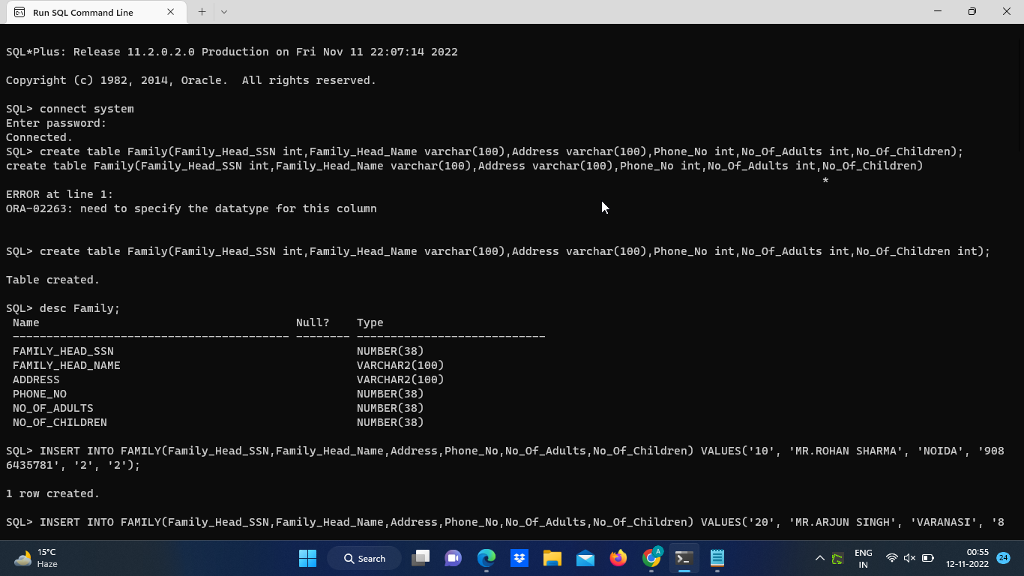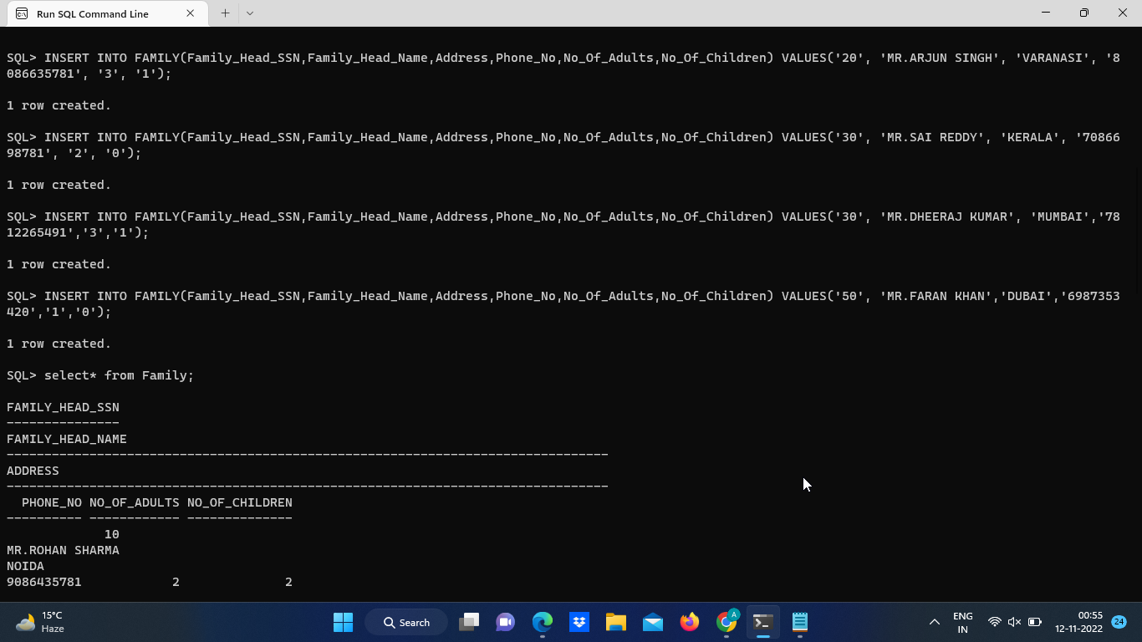

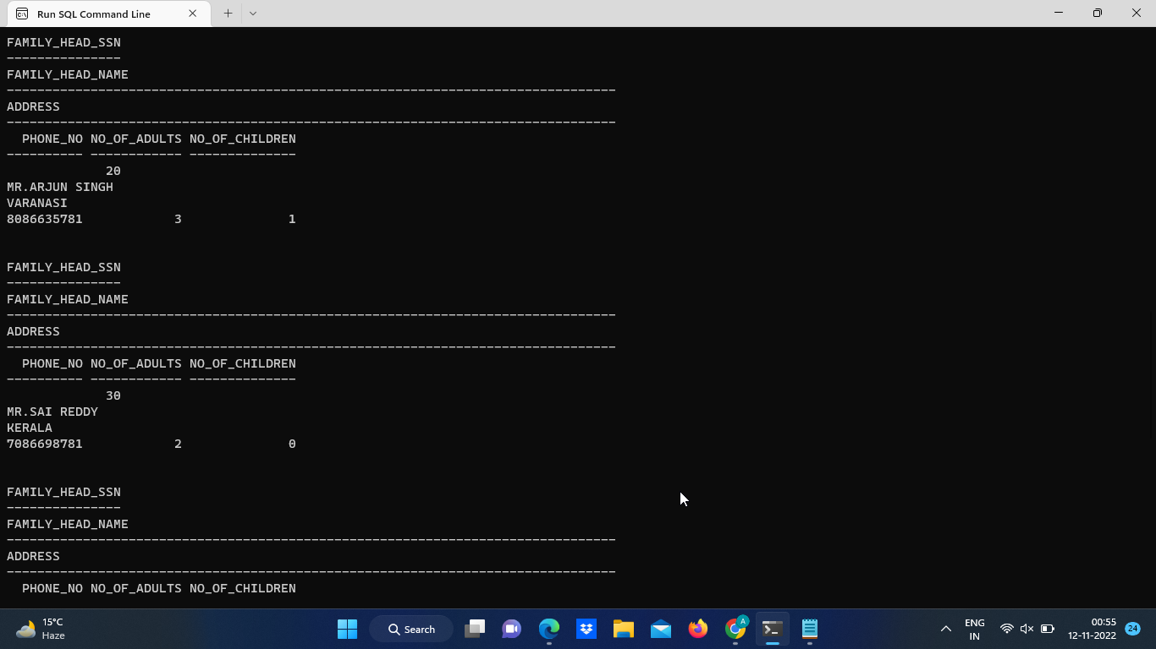

**2. Table Family Members**

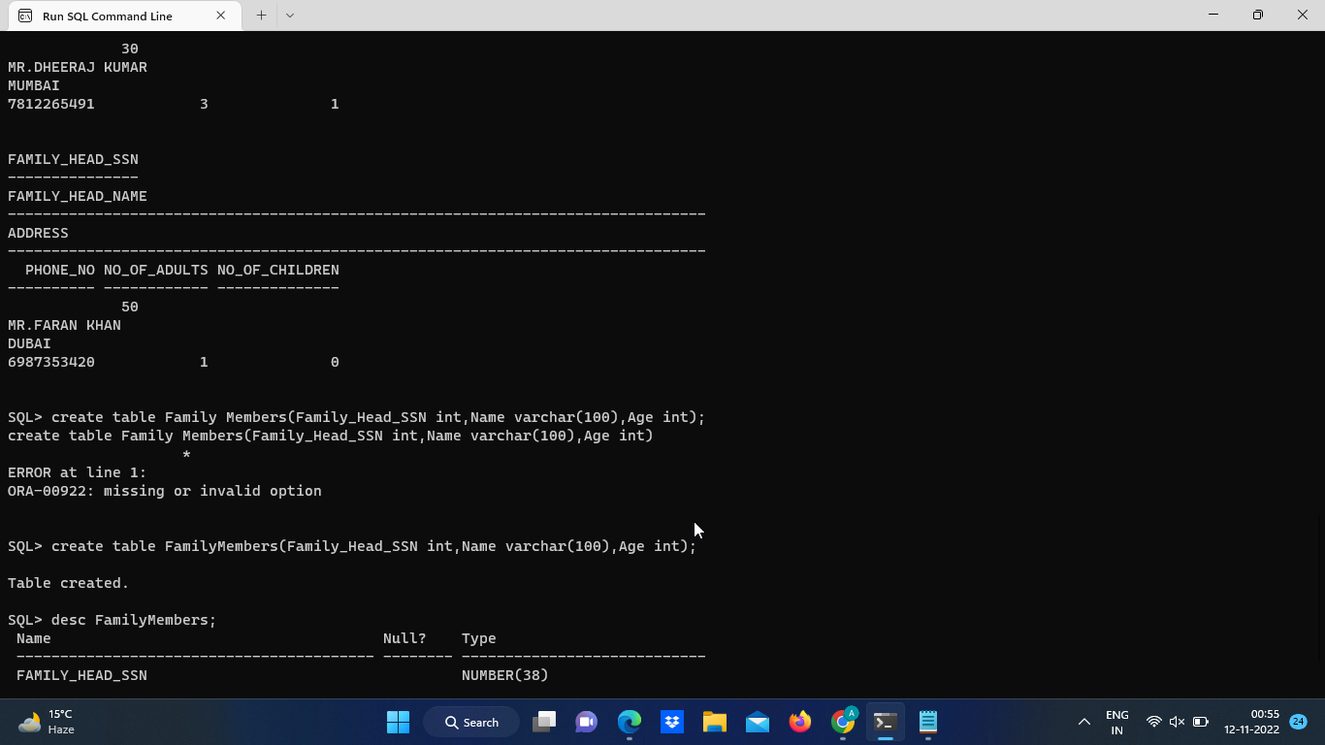

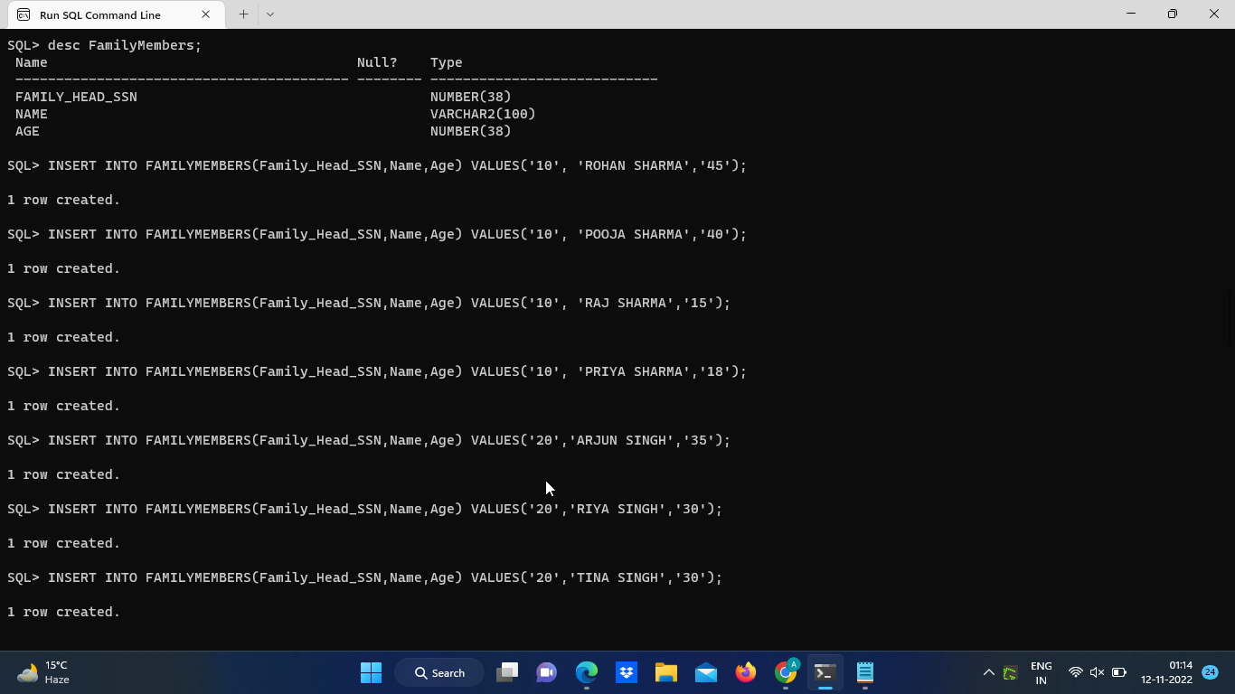

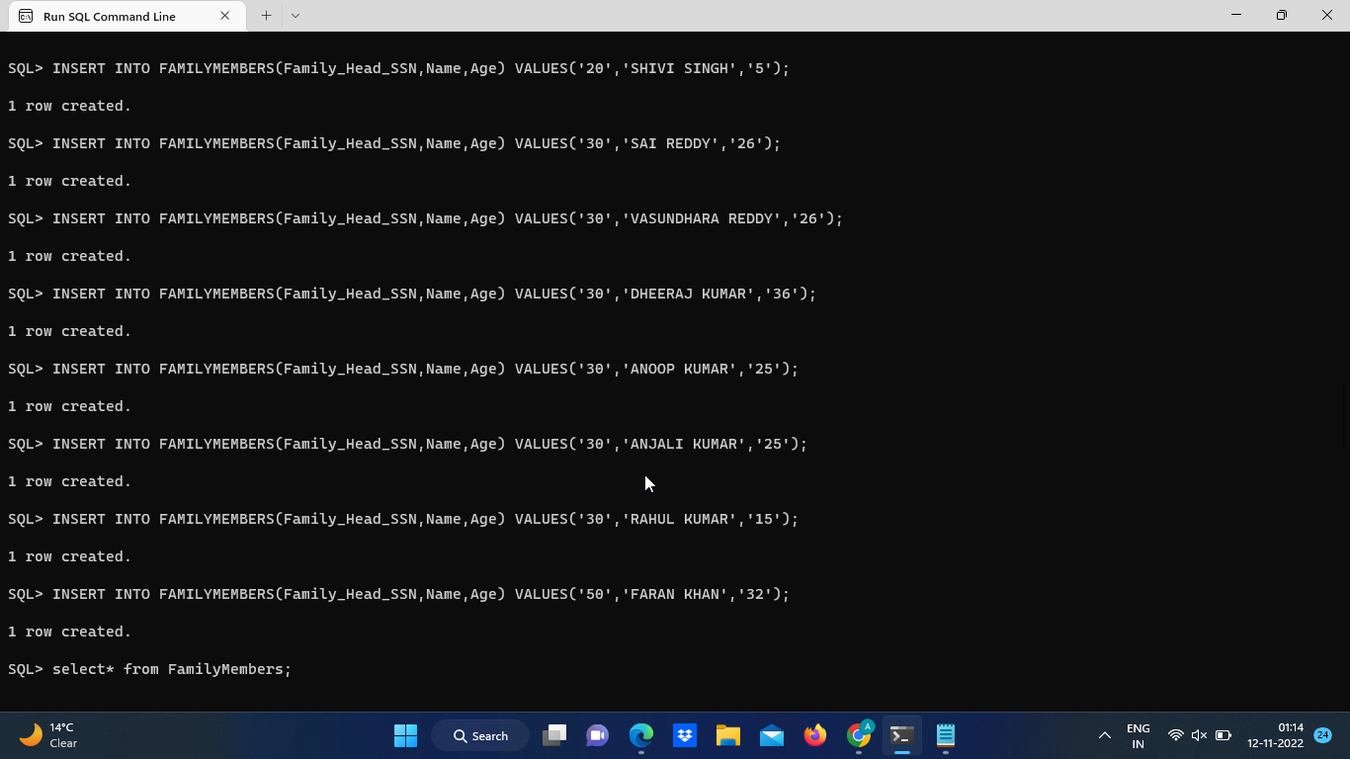

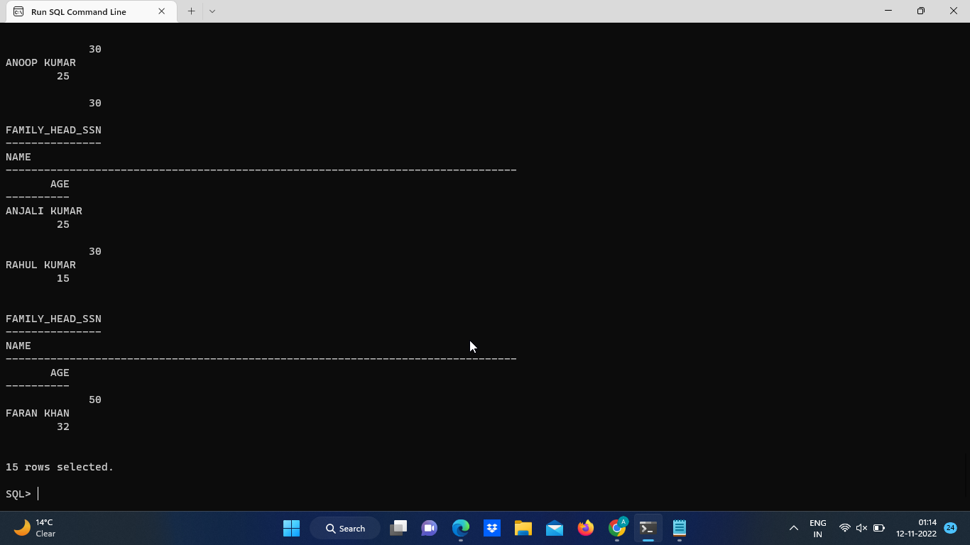

**3. Table Company**

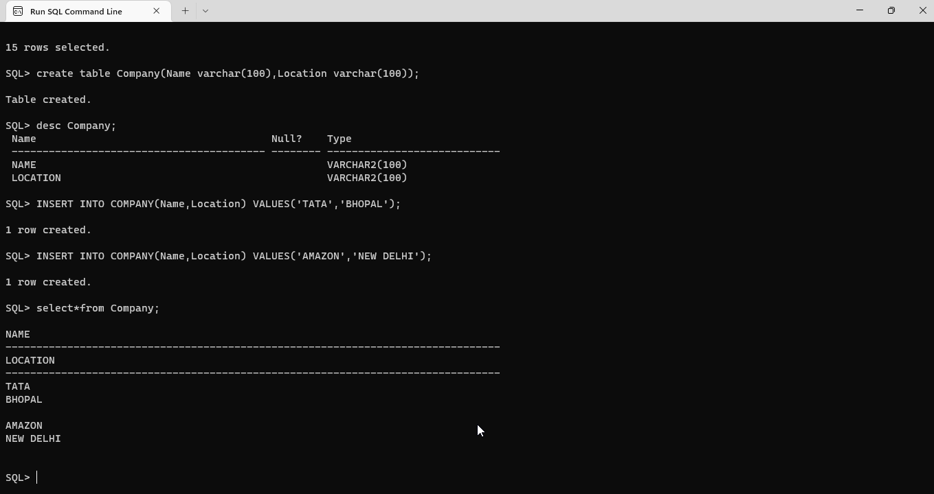

**4. Table CompanyMembers**

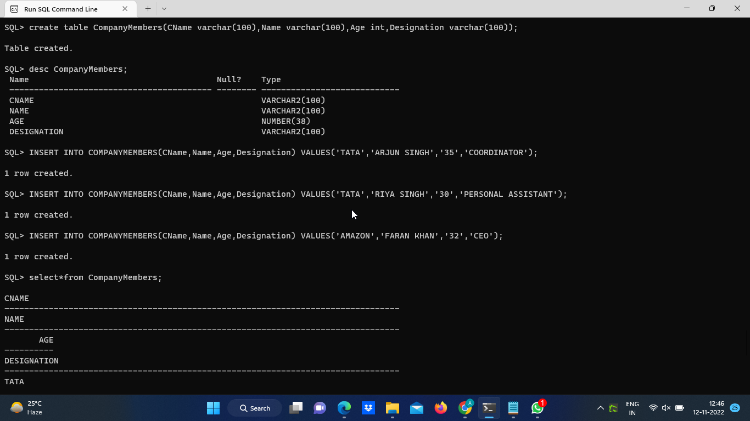

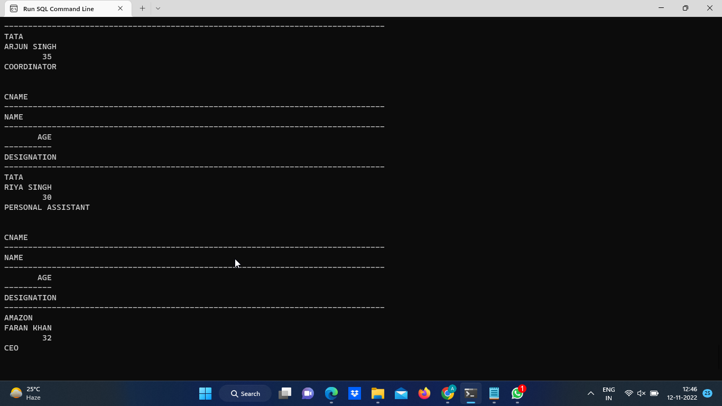

**5. Table Guest_ID**

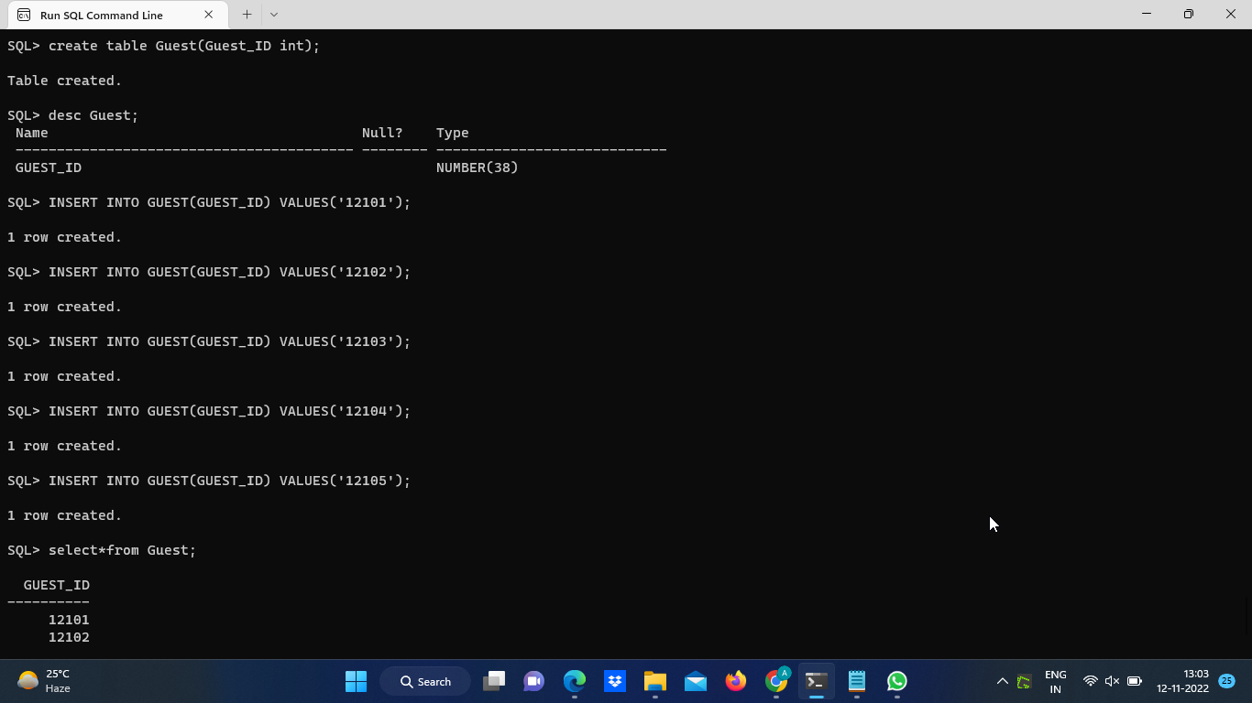

**6. Table Room**

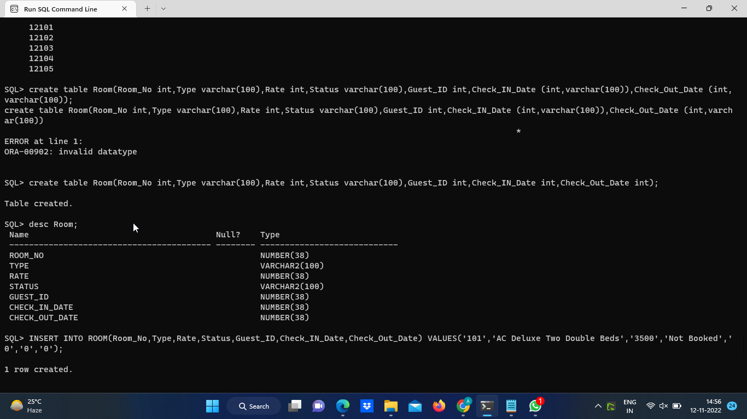

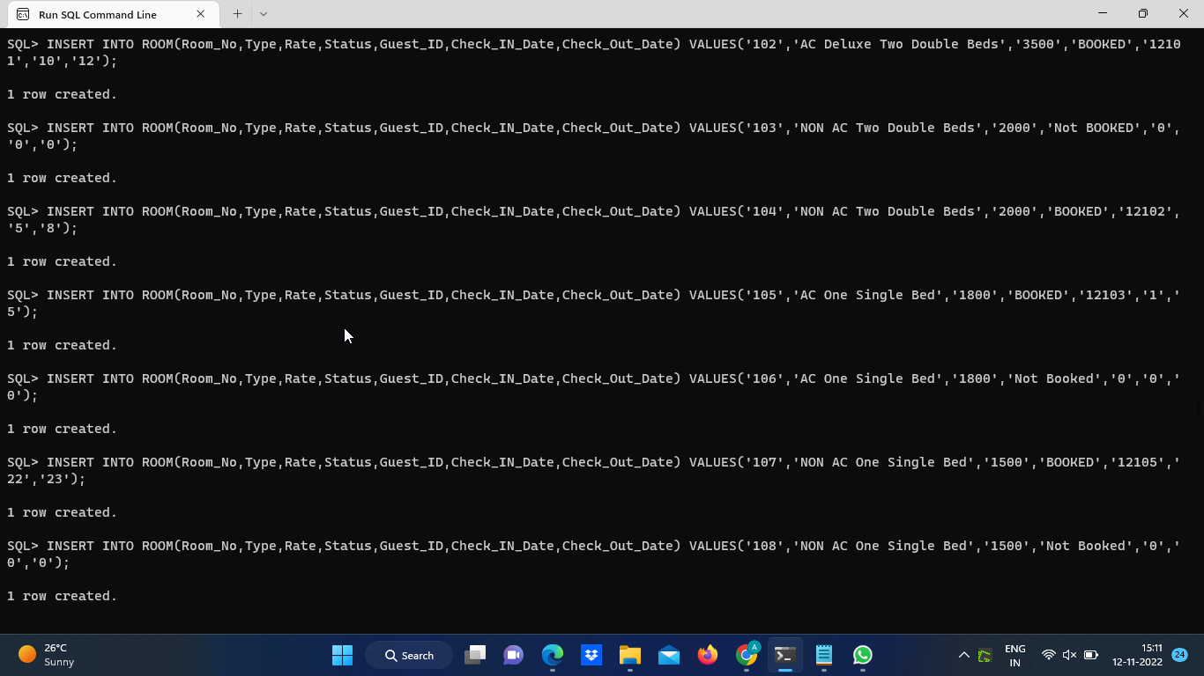

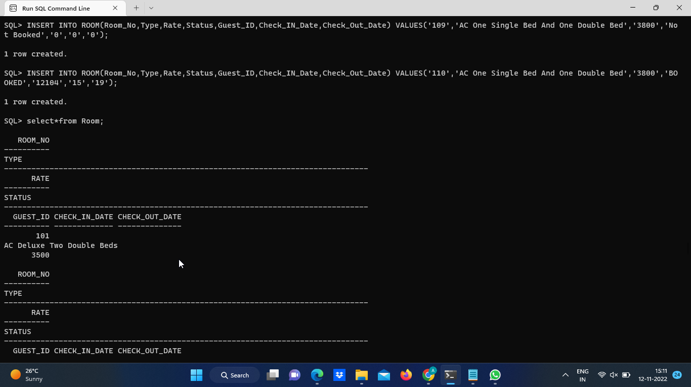

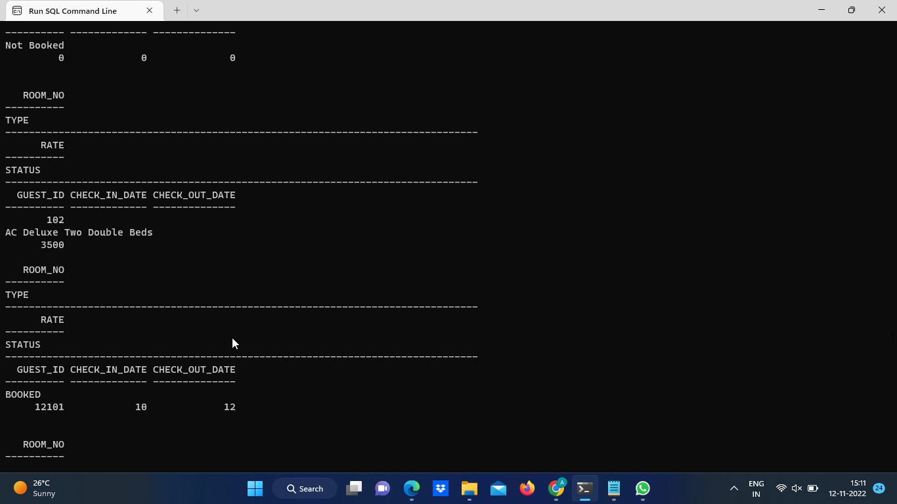

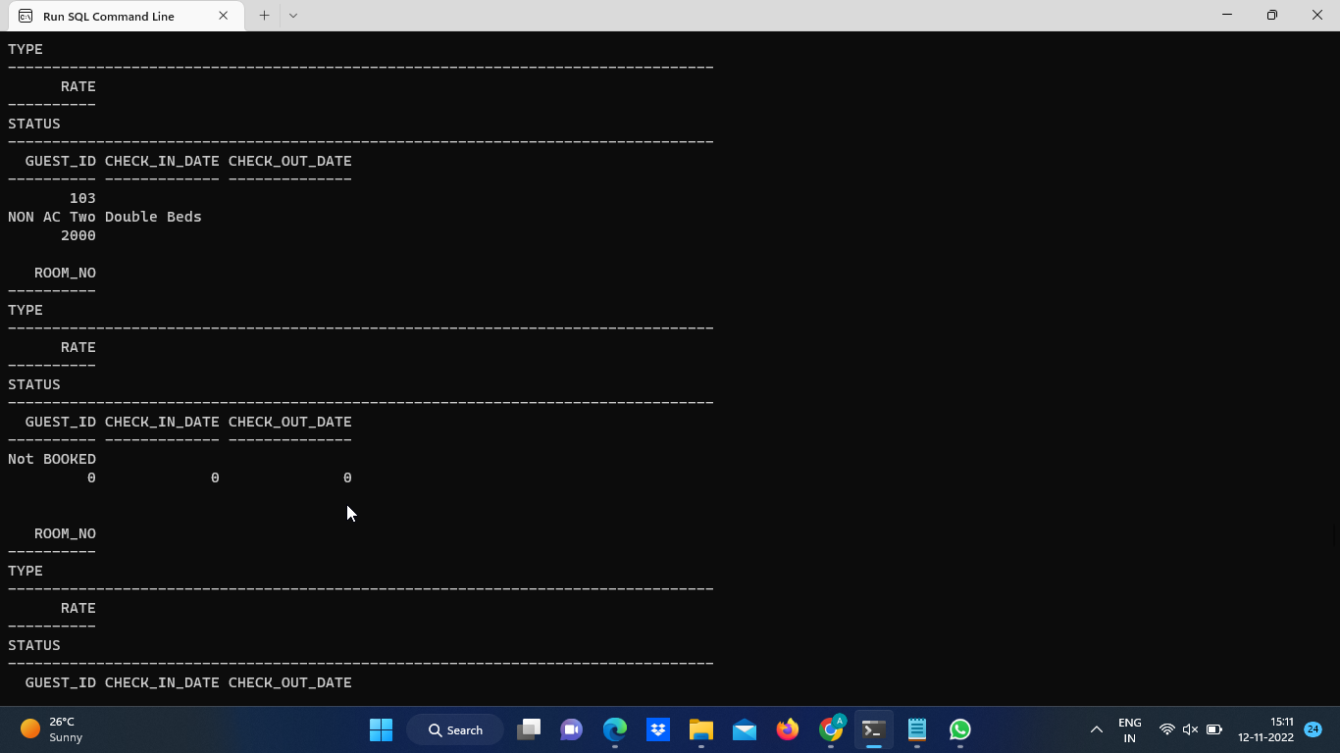

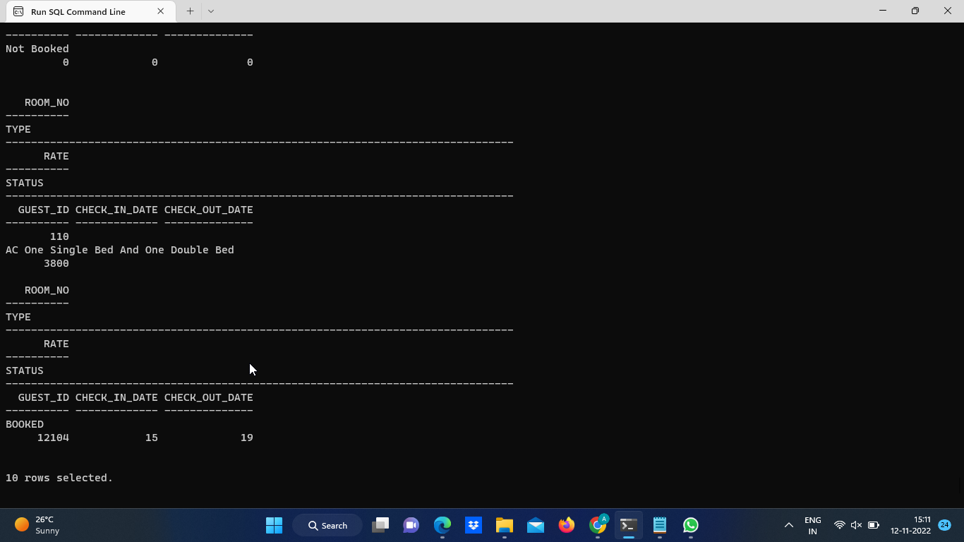

**7. Table Facilities**

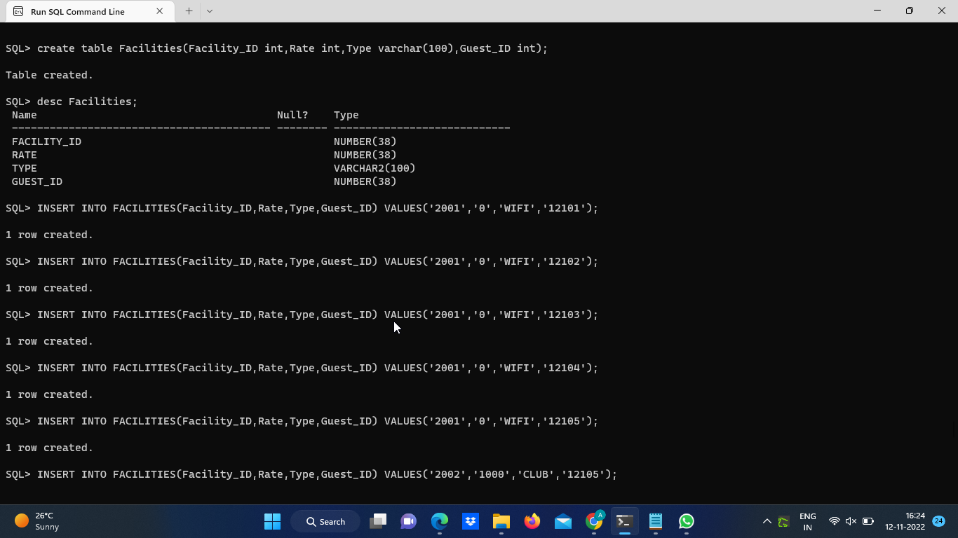

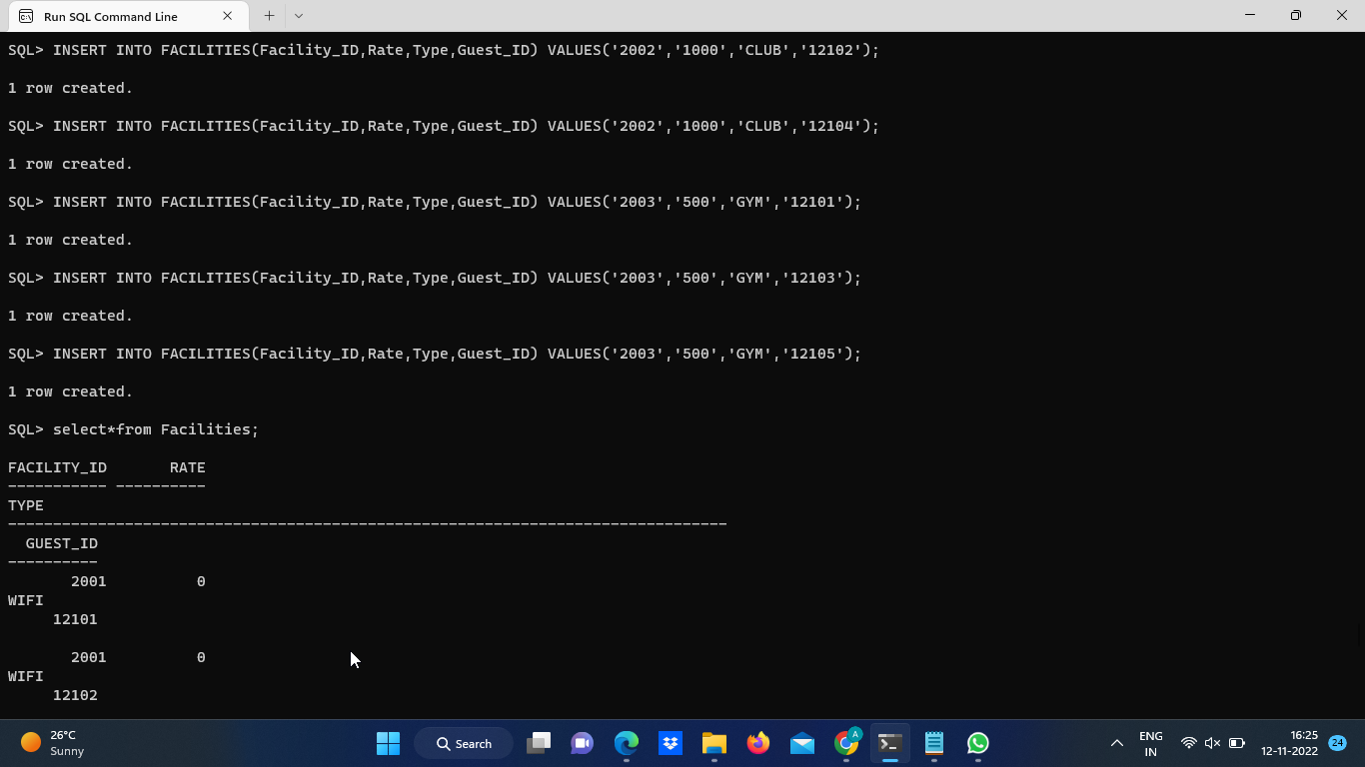

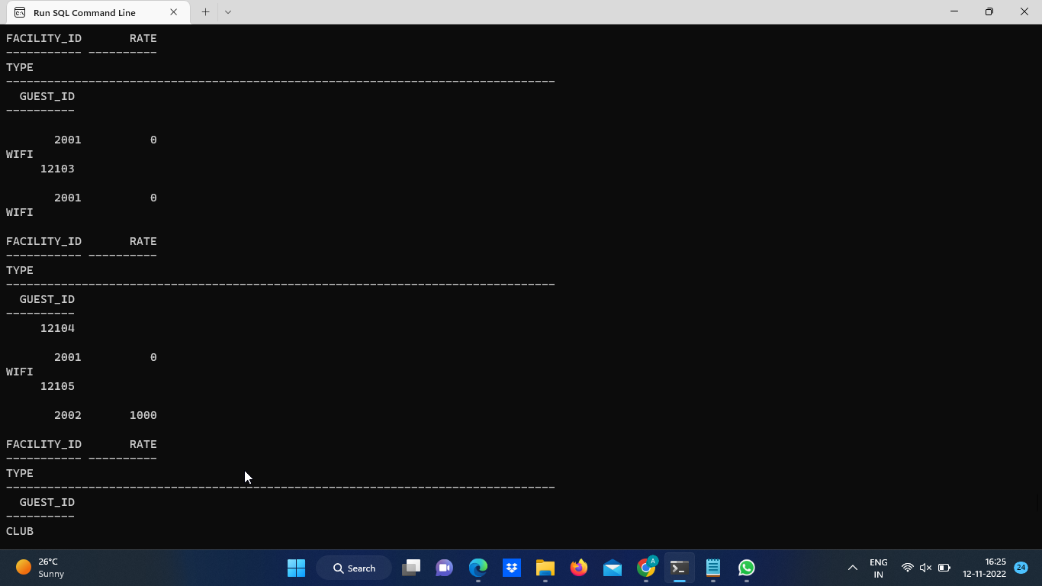

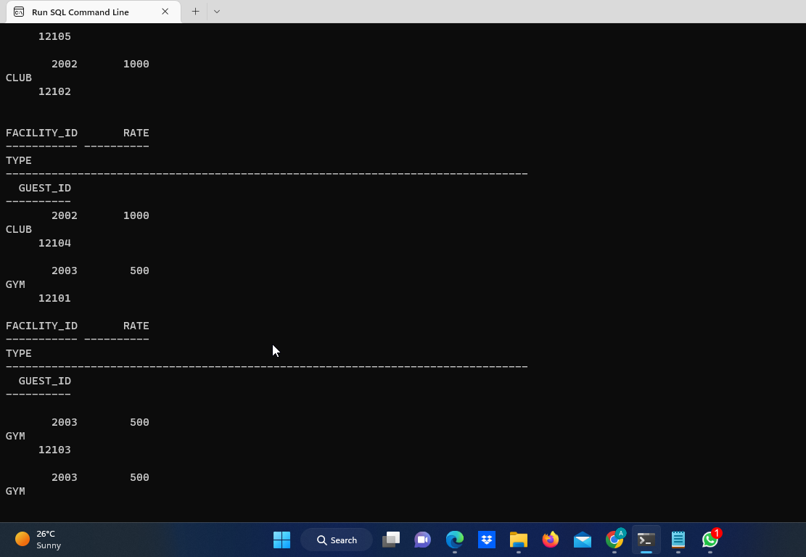

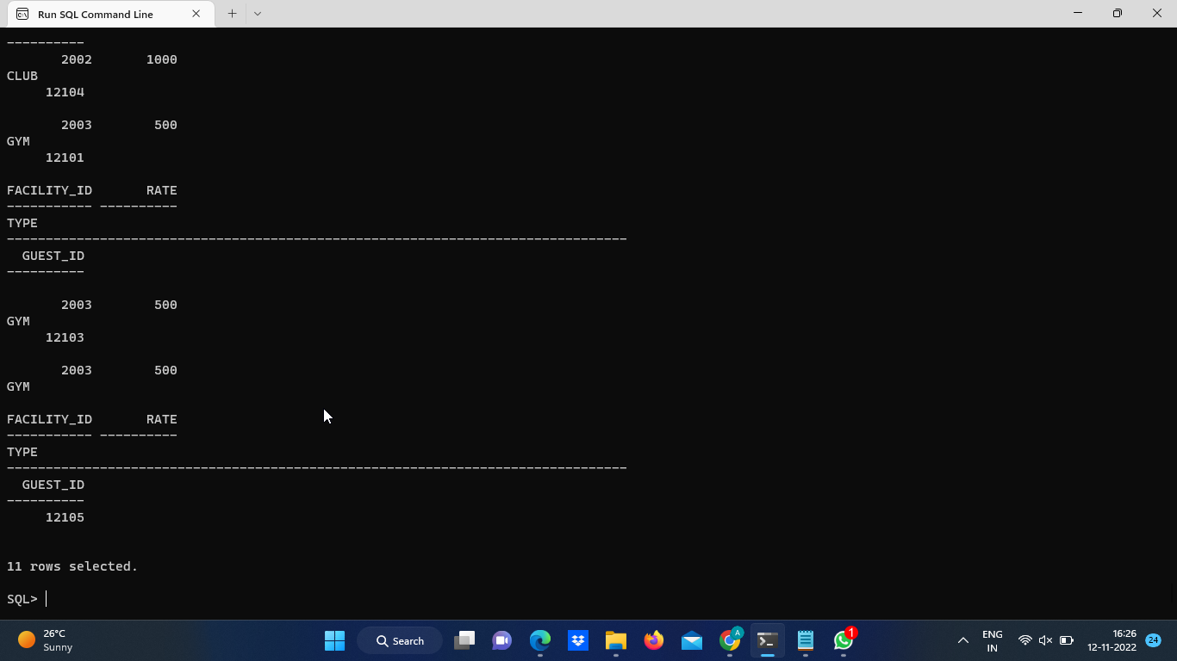

**8. Table Food**

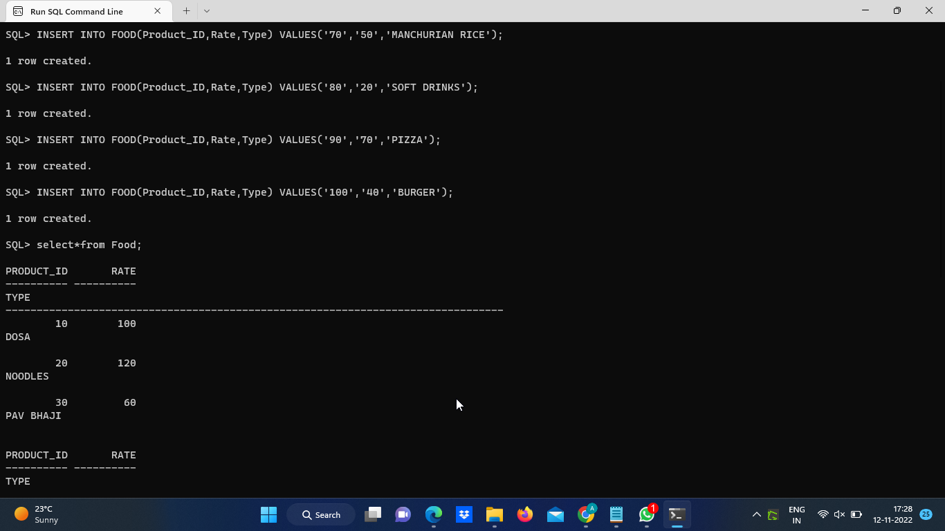

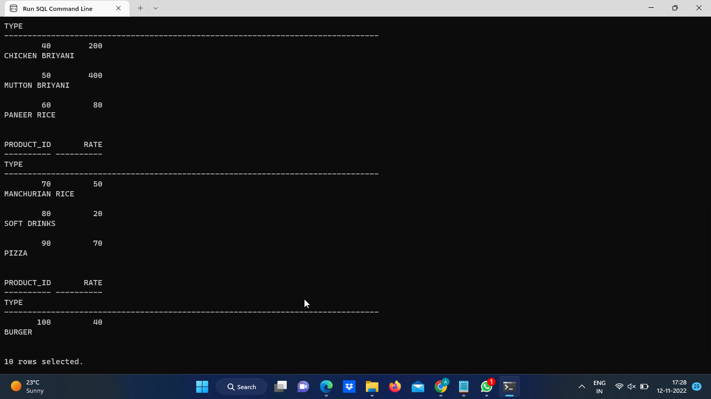

**9.Table Orders**

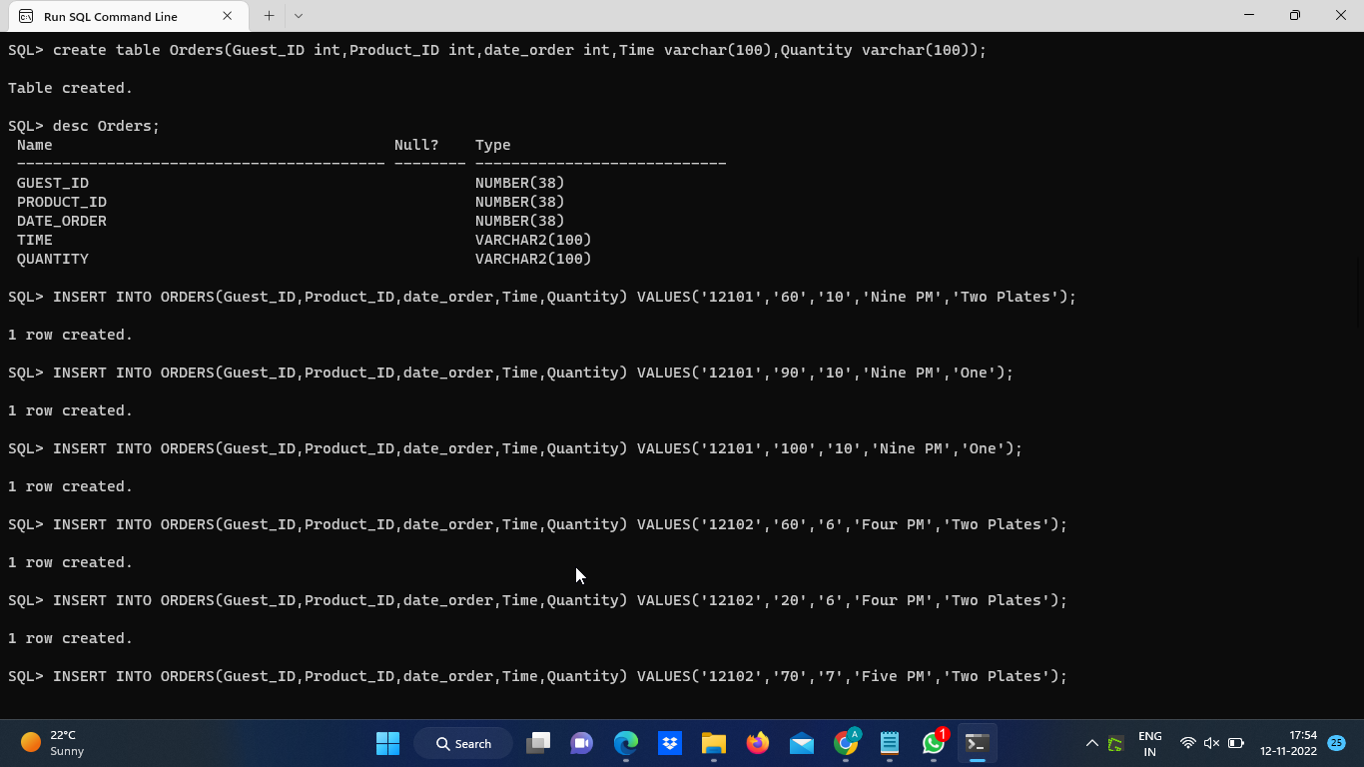

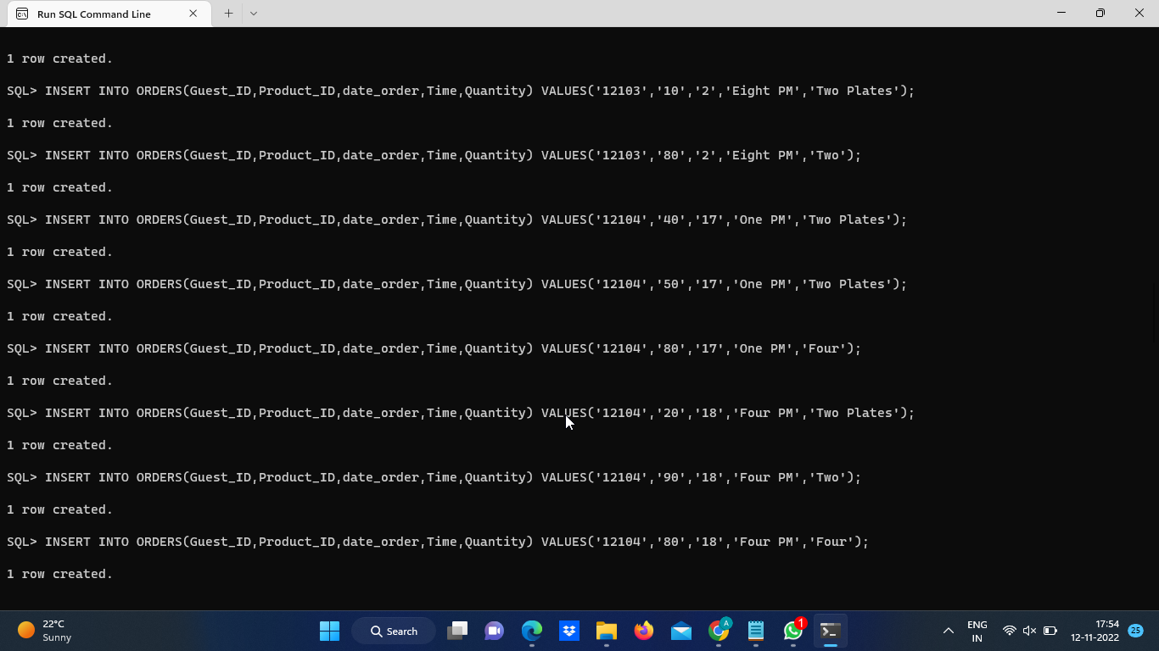

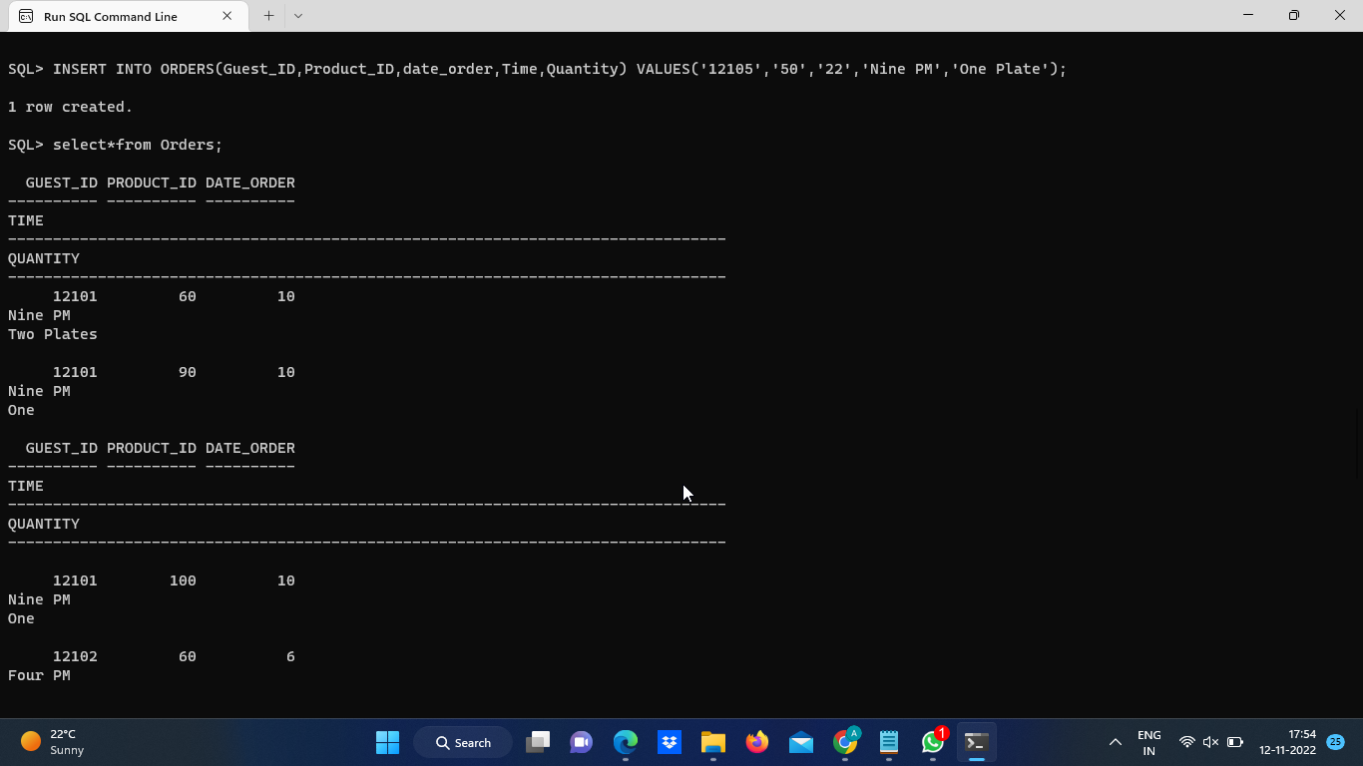

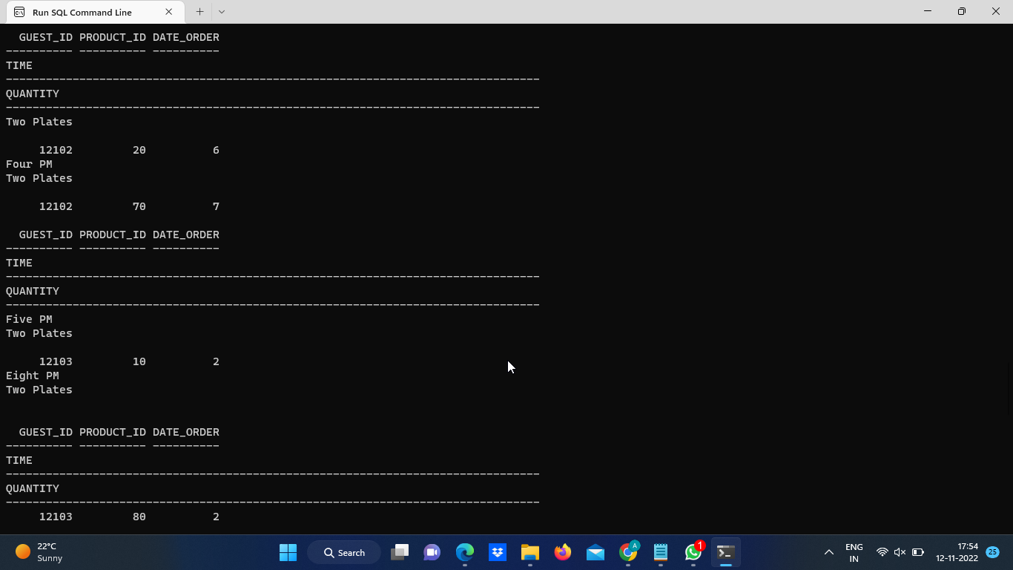

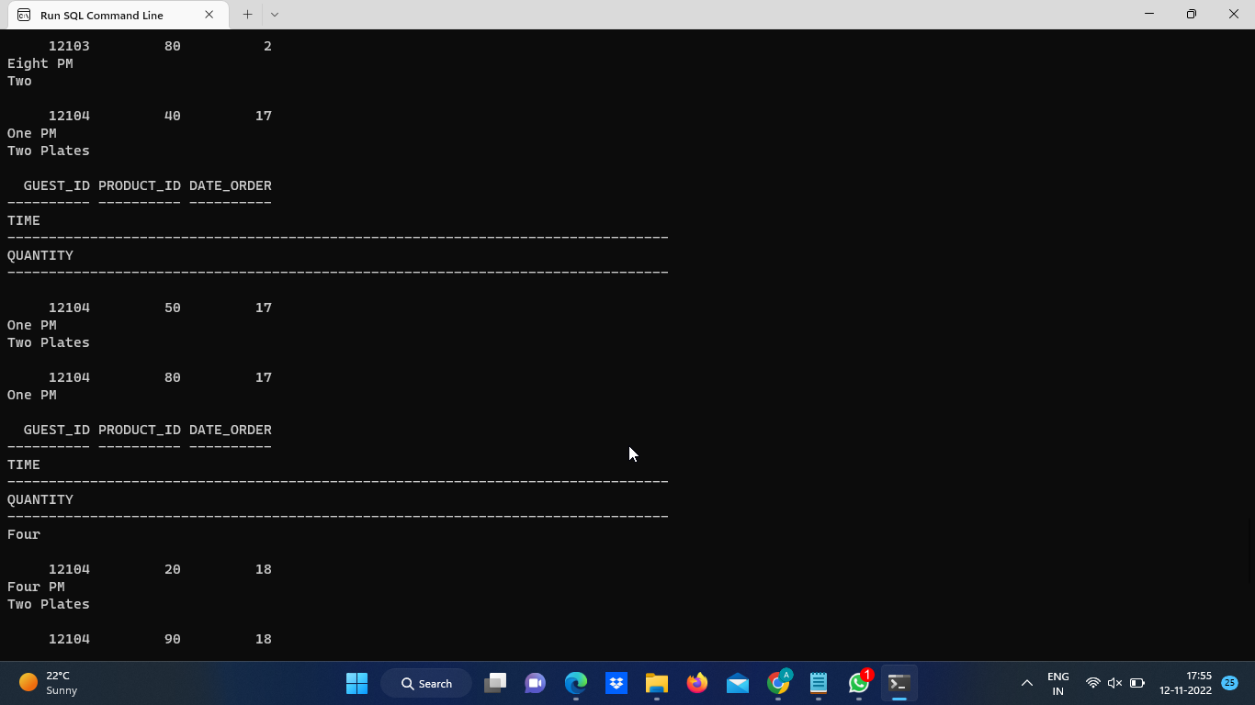

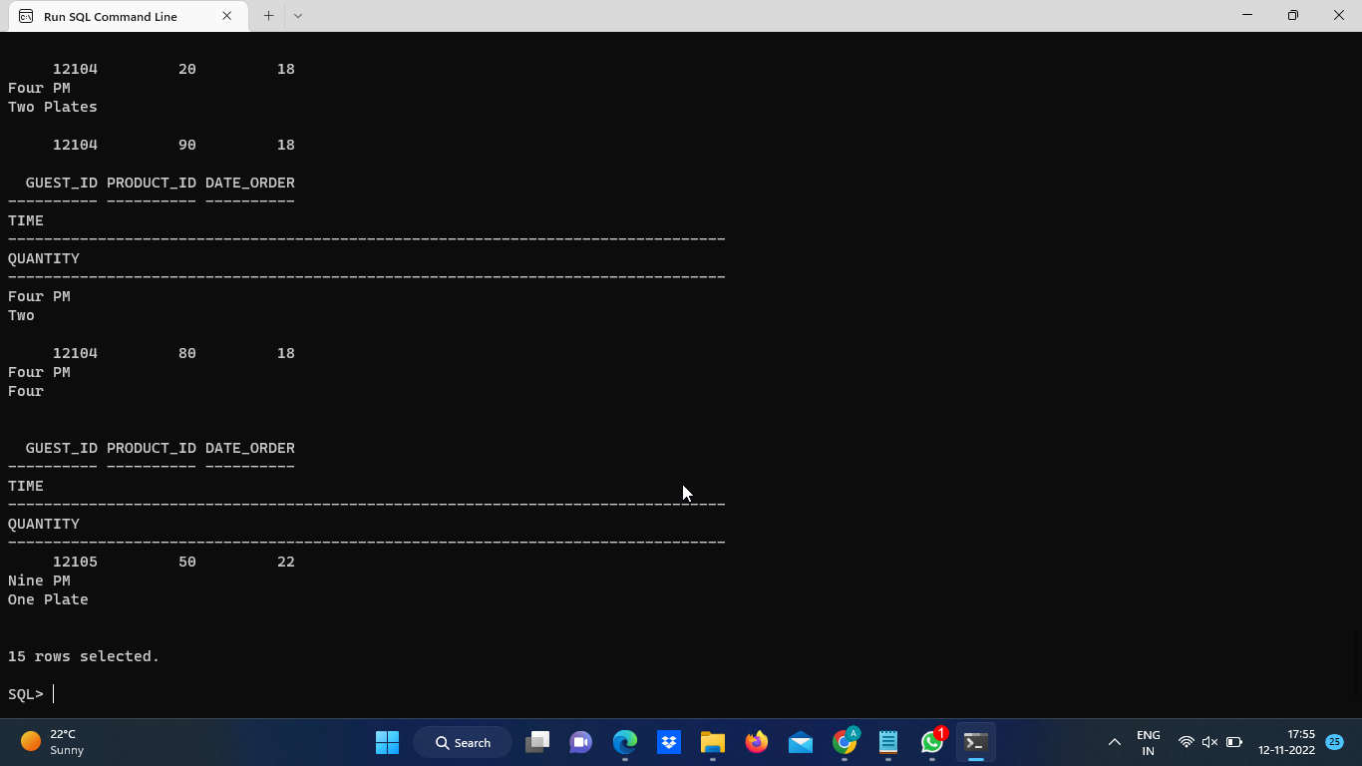

**10. Table Bill**

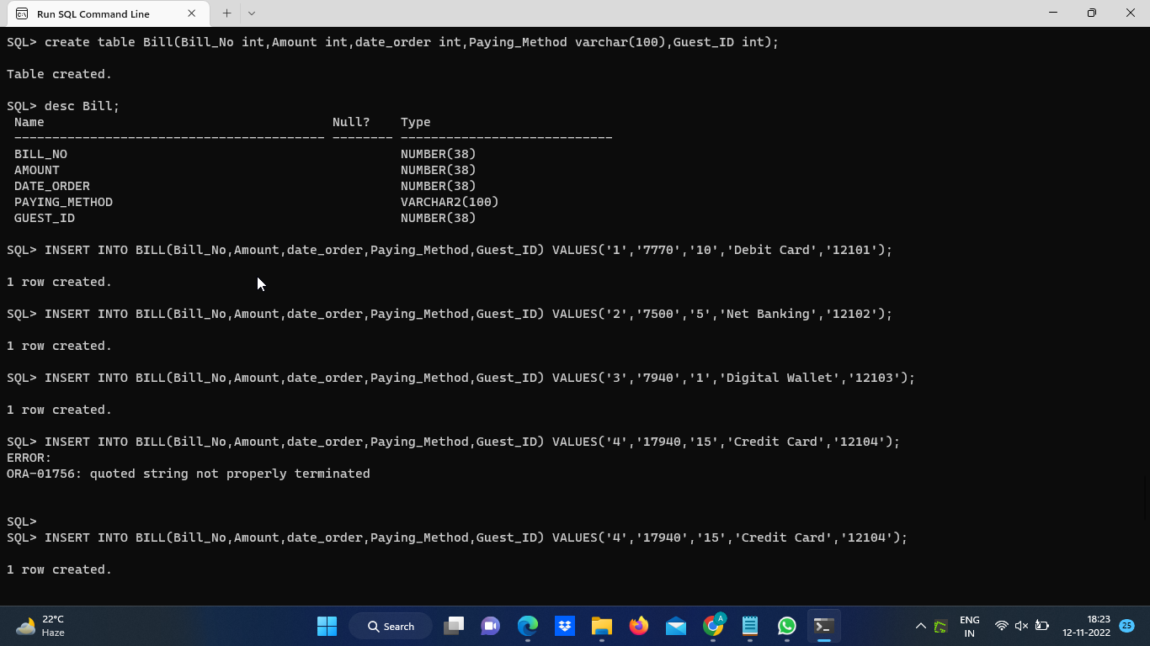

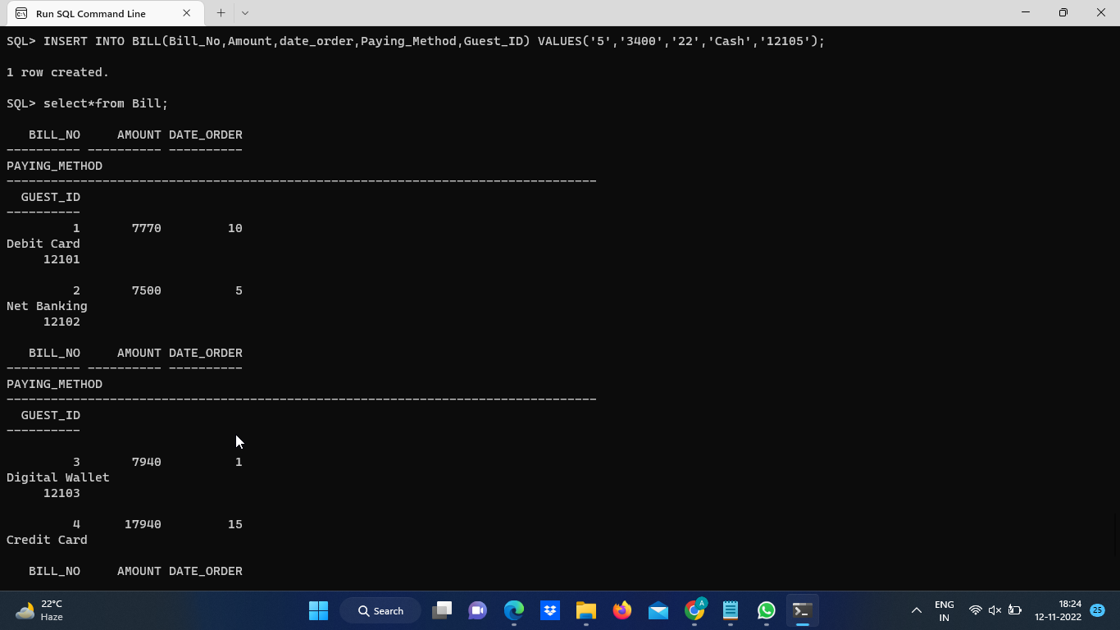

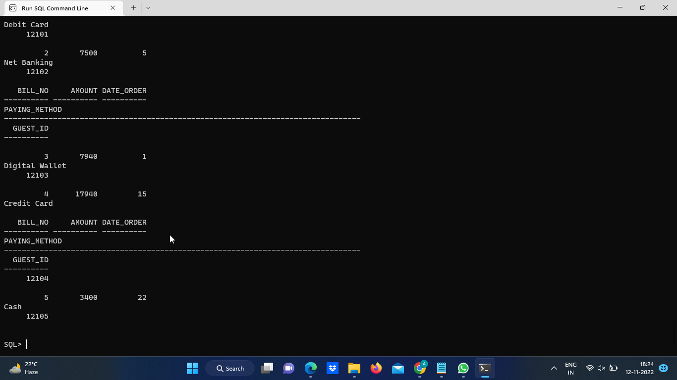

**11. Table Guest Using PL/SQL**

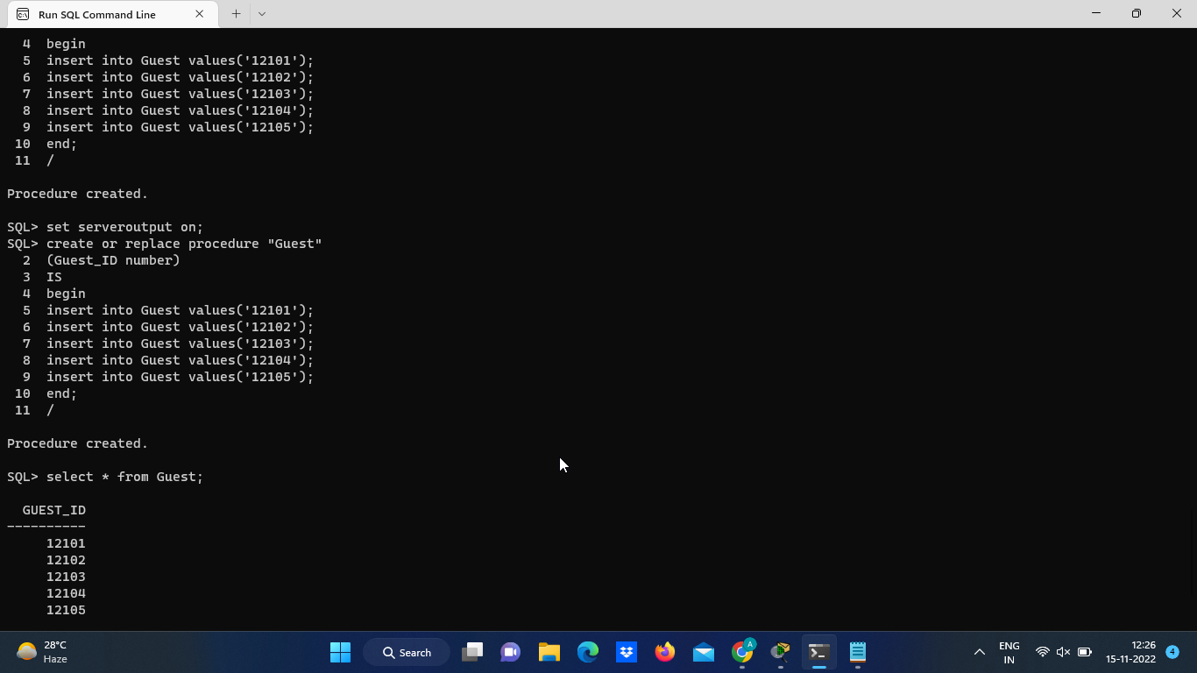

**CONCLUSION**

Finally, in the Online hotel management system, we have developed a secure, user-friendly Hotel Management System. This System can take care of each member whether its Owner or Customer. This System will Help them to properly Manage their hotel and help in growth without creating any hassle.

This system is completely secure since every user is provided with a user ID and Password so there is no chance of any unauthorized access. Online Payment, Booking, and cancellation make it easier to use. So, using this system will help in reducing the labor and provide more facility for Customer to like Hotel and visit again and again.